PROTOCOL EXCLOSURES AND CAMS NPHV 2022

1. General notes 1

2. Terminology used 2

3. Plot Layout 4

General layout – protocol type Biowild 4

General layout and (sub)plot establishment - protocol type rock dust 5

4. Measurements for protocol type Biowild AND rock dust 7

Site level 7

Plot level – general information 8

5. Measurements for protocol type Biowild 9

Measuring order 9

Plot level – vegetation and trees 9

Ground vegetation cover (entire 10x10m plot) 9

Ground vegetation plant length (entire 10x10m plot) 9

Woody saplings (>50 cm tall, entire 10x10m plot) 10

Subplot level (3x3m subplots)– small seedlings and saplings 10

6. Measurements for protocol type rock dust (from 2020 onwards) 11

Camera plot measurements (CAM) 11

Exclosure plot measurements (EXRD) 11

Exclosure subplot numbers 12

Plot level 12

Subplot level 13

Ground vegetation cover (per 5x5 subplot) 13

Ground vegetation plant length (5x5m subplot, only in RD+M- and RD-M-) 13

Woody saplings ( 5x5m subplot, only in RD+M- and RD-M-) 13

Control plot (CRD) measurements 14

Additional vegetation surveys for rock dust exclosure/camera sites (2020 onwards) 14

7. Overview of protocol type measurements and their *differences* 16

Appendix A: 2020 protocol determining 1% plots (background information only) 17

Appendix B: Selected 1% subplots 18

Appendix C: Schematic overview rock dust and planting subplots EXRD 19

Appendix D: Map of rock dust research sites 23

Appendix E: Overview of all research sites belonging to this protocol 24

Appendix F: Determinatie conifeer zaailingen 28

Appendix G: Determinatie loof- en naaldbomen (betere kwaliteit PDF beschikbaar) 29

PROTOCOL MEASUREMENTS IN EXCLOSURES AND CAMERA PLOTS

- Tree seedlings and vegetation –  
{Version August 2022 by SH & JdO}

This protocol is derived from the German Biowild project. All measurements and surveys will be repeated once a year for at least five subsequent years. In 2020 an adapted version of the protocol was added for plots that are part of the rock dust experiment (24 sites).

# 1. General notes

1. When visiting the plots, it may be necessary to replace lost or broken stakes, so always take some new stakes and a large hammer to replace lost/damaged ones.
2. Take a spray can of white tree paint to give the new stakes a white head. If the white has faded on existing stakes, repaint them as well. However, in the rock dust exclosures the blank stakes should stay blank!
3. At site H4R0-02 the vegetation plots are situated to the right of the camera (when looking in the camera’s viewing direction) instead of in front of the camera.
4. Measurements on all plots of a site should be done by the same people, even when multiple days are necessary to finish. This is to increase comparability between the pairs within a site.
5. Data files of 2020 and 2021 sometimes contain plot type “outside”. These are the boarders in the exclosures of the rock dust experiment, outside the subplots. These boarders will not be inventoried again. Data file 2021 does not contain the distinction CB and CRD yet. Data file 2020 does not contain the distinction EXRD and EXB yet.

**List of materials to bring to the field**

|  |  |
| --- | --- |
| * Stakes to replace broken of lost stakes * Hammer to drive stakes into the ground * Can of white spray paint * For transects: can of blue paint * Field forms * Map/app of locations sites * Data on site and plot information recorded in the previous year * Measuring stick/measuring tape for heights * Dendrometer (to measure Basal Area) * Compass | * Measuring tape (25 m) + tent herring * Diameter tape * Magnifying glass (≥ 10x magnification) * Plant identification keys * Collection bags/envelopes for specimens for later identification * Digital height measuring device * For transects: height telescope * For rock dust sites: 1% frame * Long wooden sate sticks (for 1% plots) * Pencils |

# 2. Terminology used

A **site** contains one or more exclosure-control pairs. In most cases, a site contains only one such pair. It may also refer to a camera site.

The **protocol type** is either *Biowild* or *Rock Dust*. Both protocols have overlap in measurements, especially on a larger scale. An overview can be found on page 16.

The Biowild protocol is in use since 2012, and is an observational study. These include exclosure-control plots and camera trap plots (without an exclosure). These plots are 10x10m and contain 4 subplots of 3x3m where all stakes have a white head (fig. 1).  
The Rock Dust protocol is in use since 2020. It concerns an experimental study with rock dust application. Exclosures contain 4 subplots of 5x5m, of which two are marked by stakes with a white head (rock dust applied) and two are marked by blank stakes (no rock dust applied) (fig. 2).

A **plot** is located in the exclosure or its associated control. It usually measures 10x10m (indicated by stakes). As for camera trap sites within the rock dust experiment, this 10x10m plot is situated within a larger 30x30m experimental plot. See figures 3, 4 and 5 for designs of the plots.

A **plot type** refers to the plot being located in an exclosure or its unfenced control. We use the following codes for plot type:

**B**iowild plots: **EXB** – exclosure that is part of the regular browse effect monitoring

(See fig. 1) network.

**CB** – unfenced control next to the exclosure. Note that also the camera

plots outside the forest (in heathlands or drift sands) are recorded,

but lack an exclosure. Such plots are also indicated by CB.

**R**ock **D**ust experiment: **EXRD** – exclosure that is part of the rock dust experiment

(See fig. 2) **CRD** – unfenced control next to exclosure (5x5 m)

**CAM** – camera plot (as part of the rock dust experiment)

Please note that in the Otterlose Bos, 9 locations have both EXB and a newer EXRD, where the CAM plot also functions as CB, and at some locations an additional CRD is present. The two exclosures can be distinguished by the size of the subplots (EXB: 3x3m; EXRD: 5x5m, see figures 1 and 2)

A **subplot** is located within a plot. In the protocol type Biowild (including the camera plots for the rock dust experiment) there are 4 subplots per plot. They are 3x3m (unfenced control/camera plot and Biowild exclosures). In the exclosures of the rock dust experiment, there are 4 subplots of 5x5m. When present, the control plot for the rock dust experiment (CRD) consists only of one 5x5m plot. See figures 3, 4 and 5.

**Figure 1.** A Biowild exclosure (EXB) right after construction. Inside the exclosure a 10x10m plot is laid out, with 4 3x3m subplots. The control (CB) is identical, lacking a fence. EXB are approximately 12x12m.

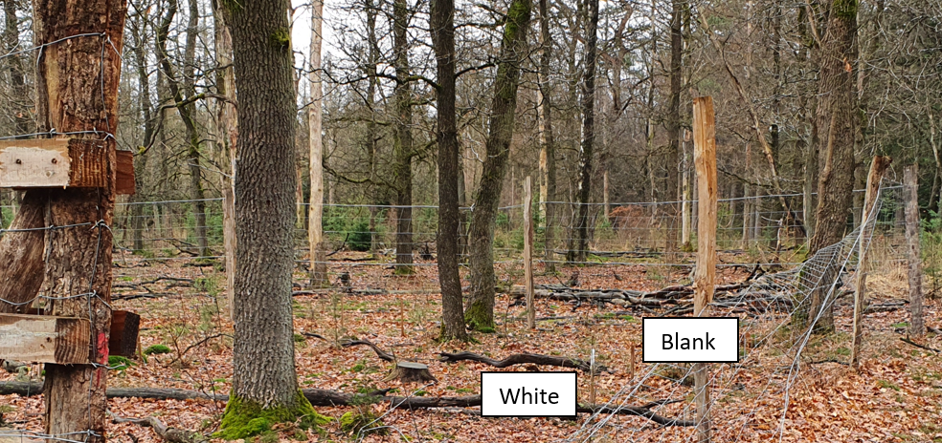  
**Figure 2.** Picture of a (damaged) rock dust exclosure (EXRD), with visible 5x5m subplot stakes that have a white head or are unpainted (blank). EXRD are approximately 13x13m.

# 3. Plot Layout

## General layout – protocol type Biowild

Each plot is oriented **north-south** as much as possible. Its corners are fixed by a stake. Stakes should be **exactly 10 m** apart (check). When the plot is not oriented exactly N-S, orientation should be based on the sides that are closest to N-S (fig. 3).

In the case of a camera plot, the orientation of the plot is determined by the camera position. The main diagonal is exactly in the direction of view of the camera (fig. 4). When camera plots are not part of the rock dust experiment, they have no exclosure associated to it.

Within each plot, the subplots are positioned in a fixed way (fig. 3 & 4), and marked by small stakes at each of the 4 corners. Stakes are **exactly 3 m** apart. In the case of a camera plot, the stakes should protrude not more than 10 cm above the ground.

The numbering of the subplots is always the same, with plot 1 in the NW corner, plot 2 in the NE corner, plot 3 in the SW corner, and plot 4 in SE corner (fig. 3). When the plot is not exactly oriented N-S, orientation should be based on the sides that are closest to N-S. In case of a camera plot, the numbering is relative to the camera position (fig. 4).

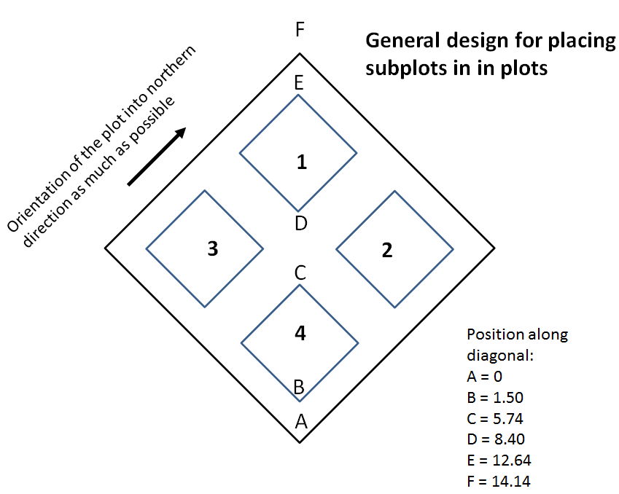

**N**

**S**

**Figure 3.** Layout of the plots and subplots in the case of fenced-control plots.

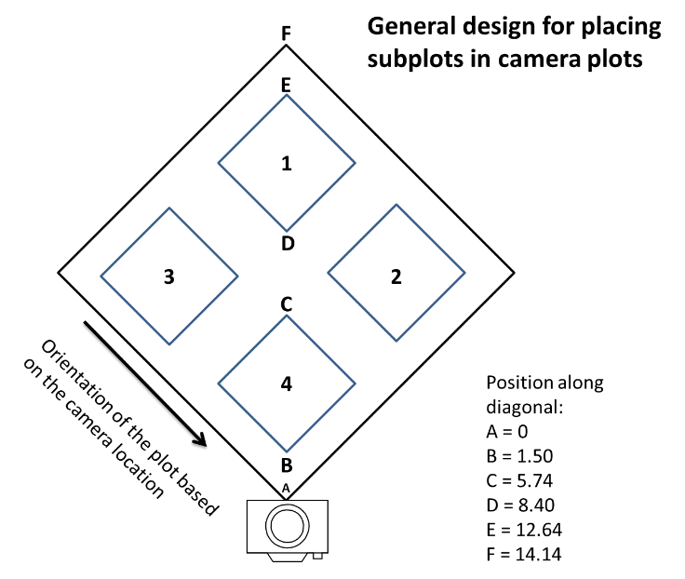

**Figure 4.** Layout of plots and subplots in front of a camera trap.

***Establishing the plots and subplots – protocol type Biowild***

*All plots were established prior to 2021. This paragraph describes the way the plots and subplots therein were laid out in the field. This text remains relevant for situations where (sub)plots need to be restored.*

To establish a 10x10 m **plot**, use a measuring tape with 0 mark at the stake A (fig. 3, in a camera plot, this is the pole holding the camera), and run the tape towards the position of the stake in the NW corner (or the position opposite of the camera) . Total length should be √ (100+100) = 14.14 m. This is the stake marked “F” in figure 3 & 4. To find the two remaining stake positions of the plot, hold the 0 mark at stake A, and hold the 20 m mark at stake F. You can then find the other two corners by holding the tape at the 10 m mark, and pull the measuring tape tight in the leftward and rightward directions. This will give you the exact locations of the remaining plot corners and produce a perfectly square plot of 10x10m.

When positioning the **subplots**, use the scheme as shown in figure 3. In this scheme, point A is the corner stake of the plot in the SE corner. **NB**: In plots with a **camera**, point A represents the position of the camera, which might not be the SE corner (fig. 4).

Use a measuring tape with 0 mark at the stake (camera pole), and run the tape towards the position of the stake in the NW corner (or the position exactly opposite of the camera) . The total length should be √ (100+100) = 14.14 m (this stake “F” was already positioned when establishing the plot). Find the points B through E using the distances indicated in fig. 3 & 4, and place the first corner stakes of subplots 4 (B and C) and 1 (D and E).

To place the first two corner stakes of subplots 3 and 2, use the same procedure over the other diagonal of the plot. Use the same distances as shown in figure 3 & 4.

To find the remaining two corners of each subplot, measure 3 m distance simultaneously from each of the two already established subplot-corner stakes. The easiest way is to put the 0 mark at one corner, the 6 m mark at the opposite corner, and pull tight at the 3 m mark of the tape.   
If a subplot needs to be repaired, the long side of a 3x3m subplot is: √ (9+9) = 4.24 m

## General layout and (sub)plot establishment - protocol type rock dust

Camera plots within the rock dust experiment were established as part of the Biowild inventory plots, and are now also adopted as part of the rock dust experiment. Therefore, reconstruction must follow the instruction above.

Control plots (CRD) are 5x5m and present at 12 out of 24 sites (see figure 5 and appendix D ). Rock dust exclosures (EXRD) are present at all 24 sites with four 5x5m subplots and 1m borders (see fig. 5). The long side of a 5x5m plot is: √ (25+25) = 7.07 m.

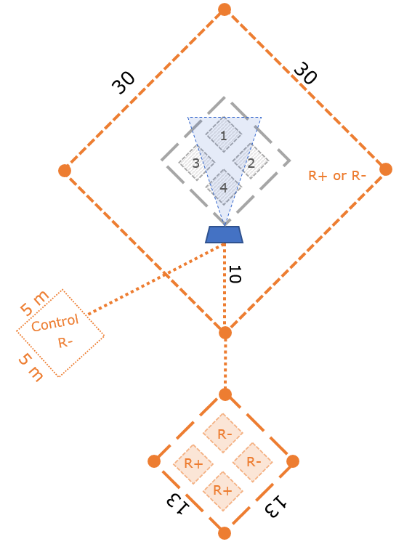

**Figure 5.** General set up of a site as part of the Rock Dust experiment, with two rock dust treatments; rock dust added (R+) or control (R-). The plot types are camera (CAM; 30x30m), exclosure (EXRD; 13x13m), and control (CRD; 5x5m). In exclosures, two adjacent subplots received rock dust and two are controls. The camera plot either fully received rock dust or was untreated. If the camera plot received rock dust, the control 5x5m plot is present, otherwise the control plot is absent. Generally, 10m from the corner stake a camera trap is situated (blue trapeze), positioned towards the longer side of the diagonal, monitoring the 10x10m and 3x3m vegetation (sub)plots (in grey). Sometimes camera trap = corner stake!. Always check the plot list (see Appendix E) for the actual configuration.

# 4. Measurements for protocol type Biowild AND rock dust

## Site level

Each site should be described by its topographical and general features. The variables that must be recorded in the field at each census are given in **BOLD**. Remaining variables were already recorded previously and are assumed to remain identical.

|  |  |
| --- | --- |
| Variable | Comment |
| **Date** | Date site level variables were inventoried |
| **Site ID** | A unique number. When camera trap is present, use camera ID as Site ID. |
| Forest area | Name of the area, this is either NP_HOGE_VELUWE or OTTERLOSE_BOS |
| Owner | Name of the owner, in this case always “Stichting NPHV”. |
| Stand nr. | Identifying number in the local forest administration |
| Animal retreat | Binary indication of site being in an animal retreat zone (1) or not (0). Note that these zones have changed recently. Check with current map.. |
| x-coordinate | GPS x-coordinate of the centre of the site (Amersfoort RD-coordinates) |
| y-coordinate | GPS y-coordinate of the centre of the site (Amersfoort RD-coordinates) |
| **Structure** | Indicates general forest structure   * Large gap (>0.5 ha) * Medium gaps (0.25 – 0.5 ha) * Small gap (<0.25 ha) * Canopy present |
| Former stand | When site is a gap, indicate previous canopy species |
| **Residual species** | When site is a gap, indicate species present as residuals |
| **Canopy species** | When site is under a canopy, indicate main canopy species |
| **Remarks** | Indicate any relevant peculiarity (for instance recent disturbances, harvest, etc.) |

## Plot level – general information

Provide information on the general environmental variables associated with the plot. The variables that must be recorded in the field at each census are given in **BOLD**. Remaining variables were already recorded previously and are assumed to remain identical.

|  |  |
| --- | --- |
| Variable | Comment |
| **Date** | Date plot level variables were inventoried |
| **Site ID** | A unique number . This should be exactly the same as Site ID in previous table. |
| **Plot ID** | A unique number, usually 1 (unless multiple plot pairs present) |
| **Plot Type** | EXB = Biowild exclosure, EXRD = rock dust exclosure, CB = control for EXB or camera plot in heathland or drift sand, CRD = 5x5 control for EXRD, CAM = camera plot in forest and associated to EXRD. |
| x-coordinate | GPS x-coordinate of the centre of the plot (RD-coordinates) |
| y-coordinate | GPS y-coordinate of the centre of the plot (RD-coordinates) |
| Soil preparation | Indicates whether the plot was prepared for regeneration   * None = no soil treatment * Flail superficial = superficial flail mowing (klepelen) * Flail deep = deep flail mowing (exposing mineral soil) * Plowing = plowing, usually for planting * Other: indicate treatment |
| Soil type* | Indicate soil type present (can be done once, including soil description) |
| **Light condition\*** | Estimate the percentage canopy cover directly above the plot. |
| **Local basal area** | Determine basal area from the centre of the plot by using an angle count (Bitterlich prism or Dendrometer, **cf = 2**), separated by tree species. Only count individuals with dbh ≥ 5 cm that are **alive**. Also count trees that are present outside the plot boarders.   * Species 1: count individuals * Species 2: count individuals * Species 3: count individuals * ...... etc   Write down the count per species, without multiplying by 2 (cf). |
| **Remarks** | Indicate any relevant peculiarity |

# 5. Measurements for protocol type Biowild

## Measuring order

Below, the measurements are described. We suggest to work in the following order:

1. Start in subplot 1 and record tree saplings <50cm, then record the individuals >50cm, and then repeat this in subplots 2, 3 and 4. Make sure you use the correct forms. When subplots are finished, continue to record the individuals >50cm in the remaining strips alongside and between the subplots.

2. Then record the vegetation covers in the entire plot. It works best if you first estimate per species, and finish with the estimation of total cover per layer for the entire plot.

3. Finish with marking and recording trees ≥5 cm dbh, and recording of the plot level information.

## Plot level – vegetation and trees

The vegetation cover is estimated for the entire 10x10 m plot. The tree layer is sampled in **two cohorts**: on the entire 10x10 m **plot** level, all individuals **> 50 cm** are recorded. On the 3x3 m **subplot** level, only tree seedlings and saplings are recorded that are **<50 cm** tall.

### Ground vegetation cover (entire 10x10m plot)

Vegetation relevés are done once a year during late summer at all sites and additionally in late spring at nutrient rich sites where spring geophytes can be expected (not the case in NP Hoge Veluwe). All plant taxa (including ferns and ground-living bryophytes) are recorded in terms of cover values directly estimated in % cover in the 100 m² plot.

The vegetation cover is recorded on a species level, separately for the **tree layer** (woody species >5 m), for the **shrub layer** (woody species 0.5 m - 5 m), for the **herb layer** (herbaceous and woody species <0.5 m), and for the **moss layer**. For cover values below 1 % (one or few individuals with low coverage) we estimate as follows: 1 to 3 individuals = 0.1%, and > 3 individuals = 0.5%.

**NB**: Correct species identification is essential! When in doubt, collect a specimen for later identification. In that case, use temporary species codes (specA, specB, etc). Also take a picture and share in the group-app. Don’t forget to write down SiteID and plot/subplot number.

Finally, we estimate the total cover per vegetation layer in the entire 100 m² plot. In addition, we also separately estimate cover of the **litter layer** (unvegetated, but not bare soil, e.g. litter and humus) and of **bare soil** (sand visible). Note that the total cover per layer can be lower than the sum of the cover values of separate species, but can never be higher. The maximum cover per layer is 100%.

### Ground vegetation plant length (entire 10x10m plot)

For plant species with cover values from **5 to 10 %** we additionally measure the **length** (not the height) of the longest shoot) of **5** randomly chosen plants. For species with **> 10 %** cover the length of **10** plants is measured. Only measure herbs, grasses, ferns, dwarf shrubs, etc. and not trees/shrubs.

### Woody saplings (>50 cm tall, entire 10x10m plot)

We assess the height and presence of browsing damage of occurring tree and shrub regeneration for each woody species per individual. This includes artificially regenerated plants.

Trees and shrubs taller than 50 cm up to 5 cm dbh are recorded on the whole 100 m² plot, measuring their exact **height** (in cm) and assessing recent (< 1 year old) **damage** marks on the **leader shoots**. When damaged, the default damage is caused by ungulates. When damage is caused by another animal (mice, voles, rabbits, hare), indicate this in “**agent**”. Record a 0 when not browsed, and a 1 if browsed. Note that every individual is recorded separately.

Also note the **subplot number** when you record the individuals. When measuring plants in the remaining strips alongside and between the subplots, give assign them to subplot number = **5**.

*Trees (dbh ≥ 5 cm, entire 10x10m plot)*

The volume of trees on our plots with a diameter at breast height (dbh) ≥ 5 cm is estimated by yield tables for the specific tree species. For this, give the tree a number (blue spray paint) and give the tree a dbh mark (horizontal stripe at 1.3 m height. Then measure and record **species**, **height** and **dbh** of the occurring trees (dbh ≥ 5 cm) in the entire 10x10m plot.

## Subplot level (3x3m subplots)– small seedlings and saplings

The woody seedlings and saplings <50 cm are only recorded in the subplots. We record the seedlings and saplings of each tree and shrub species and note **species**, exact **height**, browsing **damage** on the **leader shoot**, and **subplot number**. When damaged, the default damage is caused by ungulates. When damage is caused by another animal (mice, voles, rabbits, hare) this should be indicated in “**agent**”. Record a 0 when not browsed, and a 1 if browsed. Note that every individual is recorded separately.

We also differentiate between **seedlings < 1 year** and older seedlings. In the column “<1yr”, record a 1 when the plant is a seedling < 1 year old, or a 0 when the plant is at least one year old.

**Always check if all required data were recorded before you move to another site or plot !**

# 6. Measurements for protocol type rock dust (from 2020 onwards)

***Definition of rock dust sites and plot types***  
Part of the plots in the park are involved in a big rock dust experiment, since 2020. Site codes have the general “HxRy-0z” and “OB-Hx-0z” notation (where x = habitat type (4 or 5), y = resting area (0 or 1), and z = number (1-5)). In the park there are 24 of such sites (see appendix E for locations) and at every site a new exclosure was built, even if an old exclosure was already present (Otterlose Bos). The sites always consist of plot types CAM and EXRD, 12 also include plot type CRD. Note that in Otterlose Bos, the sites also contain the exclosures of the Biowild protocol, so there the CAM plots serve simultaneously as control plots for the Biowild exclosures (CB).   
Plot types part of the rock dust experiment (see also fig. 5):

1. **CAM** = Camera plot. The total plot is 30x30m, with a 10x10m plot in front of the camera consisting of 4 subplots of 3x3m each.
2. **EXRD** = Exclosure plot (13x13m fence, consisting of 4 subplots of 5x5m each. NB: the numbering of subplots in these exclosures is different than described for the Biowild protocol, see figure 6.
3. **CRD** = Control plot (5x5m, additional separate plot in 6 of 12 rock dust sites).

**General note:** Measurements largely follow the Biowild protocol. Any deviations from the Biowild protocol are indicated in blue.

***Site and plot information***

See site level variables and plot variables as described for the Biowild protocol (pages 7 and 8).

## Camera plot measurements (CAM)

For the general procedure, see Biowild protocol described on pages 9 and 10.

In addition to the Biowild protocol,execute the *additional measurements* as described on page 14.

## Exclosure plot measurements (EXRD)

The layout of the EXRD plots is different from the EXB plots. Also, the protocol is slightly different from the Biowild protocol as described on pages 9 and 10. Below, the protocol is repeated, with changes indicated by blue text. Also execute the additional measurements described on page 14.

## Exclosure subplot numbers

Exclosure subplot numbers are not determined by wind direction, but placement relative to the staircase in one of the corners of the exclosure. When facing the staircase (from the outside of the exclosure), the subplots are numbered from the left bottom corner to the right bottom corner in a clock-wise manner (see fig. 6). Additionally, two subplots were treated with rock dust (RD+, white corner stakes), and the other two were left untreated (RD-, blank corner stakes). Of each of these subplot groups, one is mown (M+) and one left untouched (M).

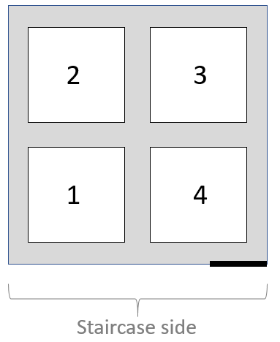

**Figure 6.** Configuration of the subplot numbers in exclosures of the rock dust experiment. The staircase is shown in the picture as a thick black line. The staircase side is the side of the exclosure on which the steps are installed. *It does not matter whether this is done in the left or right corner of this side.*

***Measuring order***

Below, the measurements are described. We suggest to work in the following order:

1. Start in subplot 1 and record tree saplings <50cm, then record the individuals >50cm, Make sure you use the correct forms. Indicate per subplot whether this is RD+ M+, RD- M+, RD+ M- or RD- M+.

2. Repeat this in subplots 2, 3 and 4.

3. Then record the vegetation covers in the entire subplot. It works best if you first estimate per species, and finish with the estimation of total cover per layer for the entire subplot.

4. Finish with marking and recording trees ≥5 cm dbh, and recording of the subplot level information.

5. Always check if all required data were recorded before you move to another subplot !

## Plot level

There are no specific measurements on plot level in the plot type EXRD. All measurements are done on a subplot level. This is the major difference with the Biowild protocol.

## Subplot level

### Ground vegetation cover (per 5x5 subplot)

Vegetation relevés are done once a year during late summer at all sites. All plant taxa (including ferns and ground-living bryophytes) are recorded in terms of cover values directly estimated in % cover in each 5x5m subplot.

The vegetation cover is recorded on a species level, separately for the **tree layer** (woody species >5 m), for the **shrub layer** (woody species 0.5 m - 5 m), for the **herb layer** (herbaceous and woody species <0.5 m), and for the **moss layer**. For cover values below 1 % (one or few individuals with low coverage) we estimate as follows: 1 to 3 individuals = 0.1%, and > 3 individuals = 0.5%.

**NB**: Correct species identification is essential! When in doubt, collect a specimen for later identification. In that case, use temporary species codes (specA, specB, etc). Also take a picture and share in the group-app. Don’t forget to write down plot/subplot number.

Finally, we estimate the total cover per vegetation layer in the entire 5x5m subplot. In addition, we also separately estimate cover of the **litter layer** (unvegetated, but not bare soil, e.g. litter and humus) and of **bare soil** (sand visible). Note that the total cover per layer can be lower than the sum of the cover values of separate species, but can never be higher.

### Ground vegetation plant length (5x5m subplot, only in RD+M- and RD-M-)

For plant species with cover values from **5 to 10 %** we additionally measure the **length** (not the height) of the longest shoot) of **5** randomly chosen plants. For species with **> 10 %** cover the length of **10** plants is measured. Only measure herbs, grasses, ferns, dwarf shrubs, etc. and not trees/shrubs.

### Woody saplings ( 5x5m subplot, only in RD+M- and RD-M-)

We assess the height and presence of browsing damage of occurring tree and shrub regeneration for each woody species per individual. This includes artificially regenerated plants.

Trees and shrubs up to 5 cm dbh are recorded on the whole 5x5m subplot, measuring their exact **height** (in cm) and assessing recent (< 1 year old) **damage** marks on the **leader shoots,** and **subplot number**. When damaged, the default damage is caused by ungulates. When damage is caused by another animal (mice, voles, rabbits, hare), indicate this in “**agent**”. Record a 0 when not browsed, and a 1 if browsed. Note that every individual is recorded separately.

Please note that in the rock dust experiment, we record individuals <50cm and >50cm simultaneously in each 5x5m subplot.

*Trees dbh ≥ 5 cm (each 5x5m subplot)*

The volume of trees on our plots with a diameter at breast height (dbh) ≥ 5 cm is estimated by yield tables for the specific tree species. For this, give the tree a number (blue spray paint) and give the tree a dbh mark (horizontal stripe at 1.3 m height. Then measure and record **species**, **height** and **dbh** of the occurring trees (dbh ≥ 5 cm) in the subplot.

## Control plot (CRD) measurements

This is the same as the protocol for the subplots in the rock dust exclosures (above). The control plot is 5x5m large, so here the plot is the same as the subplot.

## Additional vegetation surveys for rock dust exclosure/camera sites (2020 onwards)

Two subplots per plot have been selected for additional vegetation measurements in 2020, 2022, and 2023 (set up described in Appendix A). For the 4 selected subplots per location, two plots in EXRD, two plots in CAM (see the list in Appendix B for exact subplot numbers), get additional data about the vegetation. First start with **cover estimates of ground-living moss species on a subplot level** (3x3m CAM and 5x5m EXRD). For the subplots in EXRD, you can use the estimates that were recorded in the regular vegetation survey in the rock dust protocol.

Next, take **frequency estimates** of the vegetation. To do this, we divide the subplots in 1% squares (30x30 cm for 3x3m CAM subplots and 50x50 cm for 5x5m EXRD subplots) and **record per square which species have cover within that square** (binary). The species recorded are: plants of higher order than bryophytes and saplings < 50 cm.

**Note** that <1 year old conifer seedlings need to be recorded separate from >1 year old seedlings, as species distinction is very difficult for <1 year olds, and nearly impossible when the first true leaves (needles) have not appeared yet (see Appendix F).

To construct 1% squares, a frame with removable sticks will be used. Start in the **northernmost corner** of the subplot and work **from left to right, row by row (Fig. 7 and 8).** Standardised field forms (called “streeplijsten”) will be used.

Tip: use long sate sticks to move the frame over the rows and columns.

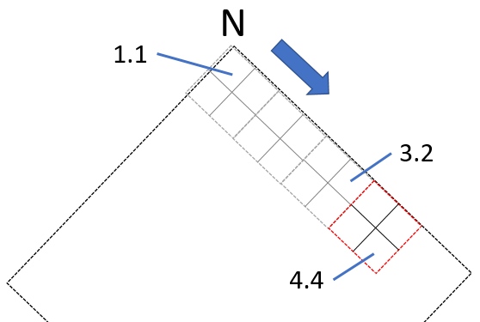

**Figure 7.** The use of the “vegetation square frame”. Starting on the northernmost side (shown by N on top), working from left to right (blue arrow). The numbers in the picture refer to “*frame number . squareplot number”*.

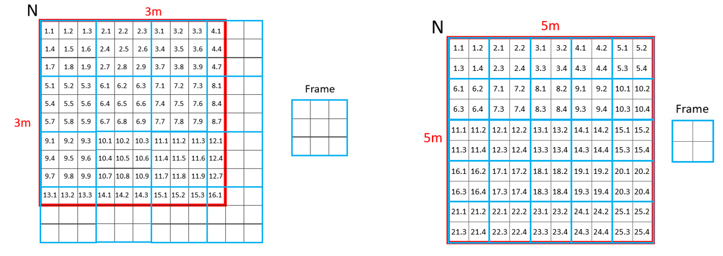

**Figure 8.** Overview of all square numbers for camera (left) and exclosure (right) subplots (subplot border in red), with frame overlay in light blue.

# 7. Overview of protocol type measurements and their *differences*

|  |  |
| --- | --- |
| Biowild type | Rock dust type |
| Site level variables: date, siteID, structure, former stand, residual species, canopy species, and remarks *p.7* | Site level variables: date, siteID, structure, former stand, residual species, canopy species, and remarks *p.7* |
| Plot level variables: date, siteID, plot Type, local basal area per species, and remarks *p.8* | Plot level variables: date, siteID, plot Type, local basal area per species, and remarks *p.8* |
| Tree dbh ≥5 cm, record: species, dbh, and top height, give number and dbh mark for entire 10x10m plot.  *p.10* | Tree dbh ≥5 cm, record: species, dbh, and top height,give number and dbh mark for entire 10x10m plot in CAM plot. In EXRD and CRD, only in the subplot(s).  *p.10,14* |
| Tree and shrub species >50cm <5cm dbh, record: subplot number, species, height, damage, and agent.  in entire 10x10m plot.  *p.10* | Tree and shrub species >50cm <5cm dbh, record: sub­plot number,species, height, damage, and agent. In entire 10x10m plot for CAM plots or per subplot for rock dust exclosures (EXRD) and their controls (CRD).  *p.10,13* |
| Sapling <50cm, record: subplot number,species, height, damage, agent, and whether seedling <1yr or not. On sub-plot-level (3x3m).  *p.10* | Sapling <50cm, record: subplot number, species, height, damage, agent, and whether seedling <1yr or not. On subplot level (3x3m CAM or 5x5m EXRD, CRD)  *p.10,13* |
| Ground vegetation cover per layer AND per species, for tree, shrub, herb, moss, litter & bare soil layers. On plot-level (10x10m).  *p.9* | Ground vegetation cover per layer AND per species, on the: tree, shrub, herb, moss, litter & bare soil layers. On plot-level (10x10m) for CAM, on subplot level (5x5m) for EXRD and CRD.  *p.9,13* |
|  | In CAM and EXRD: Ground vegetation cover 1% squares: record species cover presence per square for plants of higher order than bryophytes and saplings < 50 cm. Estimate moss cover on subplot level.  *p. 14,15* |
| Ground vegetation length: Record length of 5 individuals for 5-10% cover and 10 individuals for ≥ 10% cover. On plot-level (10x10m) *p.9* | Ground vegetation length: Record length of 5 individuals for 5-10% cover and 10 individuals for ≥ 10% cover. On plot-level (10x10m) for CAM. On subplot level (5x5m) for EXRD and CRD. Measure only in subplots that were not mown.  *p.9,13* |
| Subplot numbers in EXB, CB and CAM based on wind direction  *p. 4* | Subplot numbers in CAM based on wind direction, but EXRD based on staircase clockwise. In CRD, plot=subplot, 5x5m .  *p. 6* |

# Appendix A: 2020 protocol determining 1% plots (background information only)

The exclosure and camera plot types both consist of 4 subplots. Within the rock dust addition experiment with a BACI design, 2 subplots were chosen in 2020 for a more precise vegetation cover inventory, this is done via a 2-step procedure.

**Step 1**

For all 8 subplots (4 in CAM and 4 in EXRD), cover values in % were estimated for vegetation layers: **tree layer** (woody species >5 m), **shrub layer** (woody species 0.5 m - 5 m), **herb layer** (herbaceous and woody species <0.5 m), **moss layer**, **litter layer** (unvegetated, but not bare soil, e.g. litter and humus), and for **bare soil** (sand visible). No discrimination was made between specific species, as an additional estimate % cover of the **dominant** and **sub-dominant herbaceous species** was provided.

NOTE: Organisation-wise it was not possible to first determine % cover of all the species per layer, as step 2 of this protocol was executed while students in the field executed the regular Biowild/rock dust inventory. Thereafter, students got the results from step 2 and executed the 1% inventory (on the same day for most plots).

**Step 2**

The cover estimates were delivered to Sylvana Harmsen, after which an non-random selection of the 4 subplots was made. The selection was non-random, to select the 4 plots which were most similar to each other, such that future changes in vegetation composition were most likely due to treatment effects instead of differences in vegetation composition at the start (different starting position).

PCA ordination was run for layer cover values, (sub)dominant cover values, and a combination of both. The three species+plots diagrams were evaluated, as well as the raw data. Together with the requisite that in the exclosure the rock dust treatment and control plots had to be adjacent, a choice was made accordingly. **A list of the selected subplots is provided in Appendix B.**

The plots were measured as described in the main protocol.

# Appendix B: Selected 1% subplots

The list below gives an overview of the selected subplots for the additional 1% vegetation inventory. Students painted the rock dust stakes in the EXRD white, so of the selected plots in the table below, one plot should have white corner stakes and the other should have blank corner stakes.

|  |  |  |  |  |
| --- | --- | --- | --- | --- |
| **Nr** | **LOCATION** | **CAMERA PLOTS** | **EXCLOSURE PLOTS** | **PLANTING Exclosure\*** |
| 1 | OBH401 | 1+4 | 1+4 | 2+3 |
| 2 | OBH402 | 1+2 | 1+2 | 3+4 |
| 3 | OBH404 | 1+2 | 1+2 | 3+4 |
| 4 | OBH405 | 3+4 | 3+4 | 1+2 |
| 5 | OBH501 | 3+4 | 1+2 | 3+4 |
| 6 | OBH502 | 1+2 | 3+4 | 1+2 |
| 7 | OBH503 | 1+2 | 1+4 | 2+3 |
| 8 | OBH504 | 1+3 | 3+4 | 1+2 |
| 9 | OBH505 | 1+2 | 1+2 | 3+4 |
| 10 | H4R0_01 | 1+2 | 1+4 | 2+3 |
| 11 | H4R0_02 | 1+3 | 1+4 | 2+3 |
| 12 | H4R0_03 | 1+2 | 1+2 | 3+4 |
| 13 | H4R0_04 | 1+3 | 1+2 | 3+4 |
| 14 | H4R1_01 | 2+4 | 3+4 | 1+2 |
| 15 | H4R1_02 | 1+3 | 1+4 | 2+3 |
| 16 | H4R1_03 | 2+3 | 3+4 | 1+2 |
| 17 | H4R1_04 | 1+4 | 3+4 | 1+2 |
| 18 | H5R0_01 | 1+4 | 1+2 | 3+4 |
| 19 | H5R0_02 | 1+4 | 1+4 | 2+3 |
| 20 | H5R0_03 | 1+3 | 1+2 | 3+4 |
| 21 | H5R1_01 | 3+4 | 1+2 | 3+4 |
| 22 | H5R1_02 | 1+3 | 1+4 | 2+3 |
| 23 | H5R1_03 | 1+3 | 3+4 | 1+2 |
| 24 | H5R1_04 | 3+4 | 2+3 | 1+4 |

*PLANTING = mowed subplots in 2022 and planted rowan 2022 to measure leaf chemistry in 2023 or 2024.

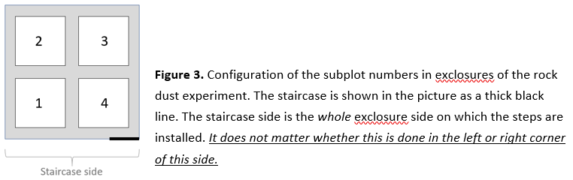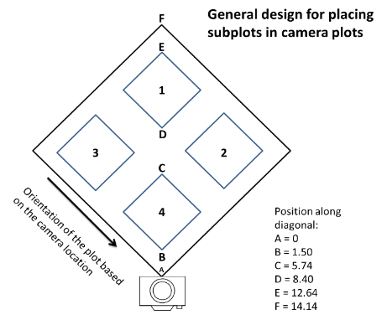

**Figure B1.** Overview plot numbers camera

**Figure B2.** Overview plot numbers exclosure.

# Appendix C: Schematic overview rock dust and planting subplots EXRD

The following pages give a schematic overview of the subplots within all the rock dust exclosures (24). The blue filled subplots are subplots that received 10t/ha Soilfeed early 2020. The white open subplots are the controls where no rock dust was applied. The subplots with a “1%” sign are the EXRD subplots that are selected for the 1% square inventory. The subplots with a “plant” sign are the ones that are mown late 2022 and where rowan was planted late 2022.

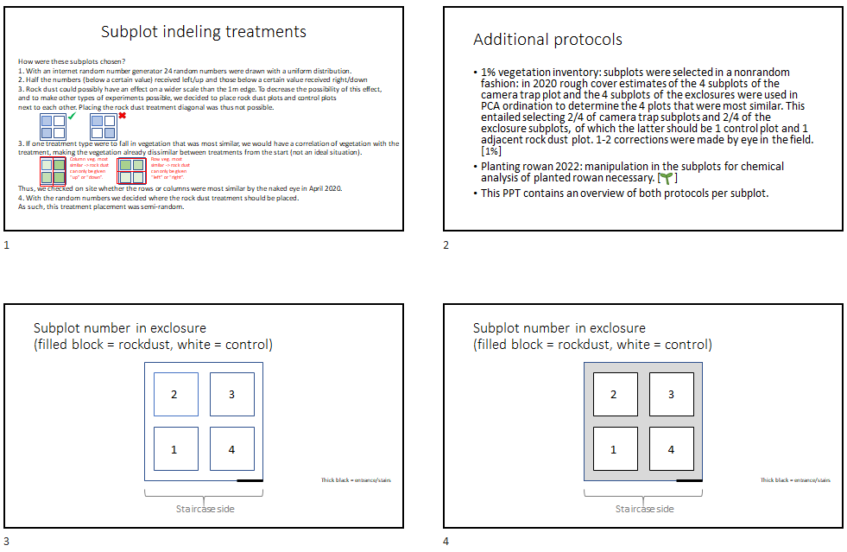

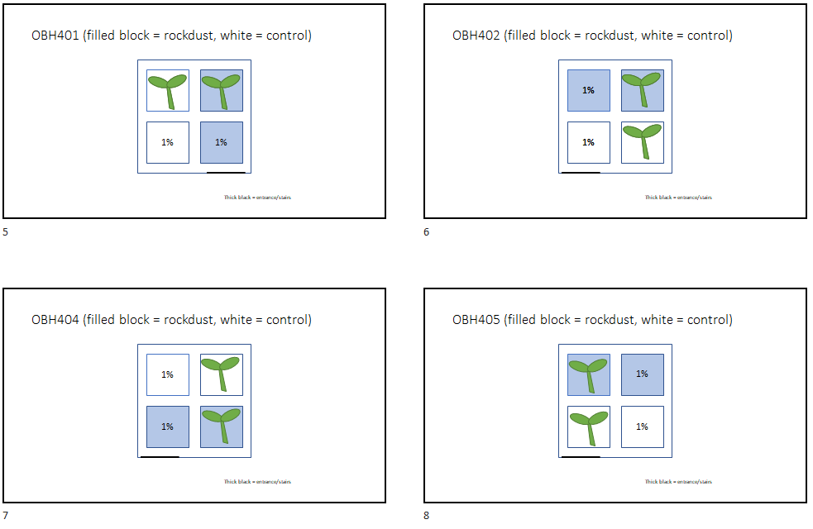

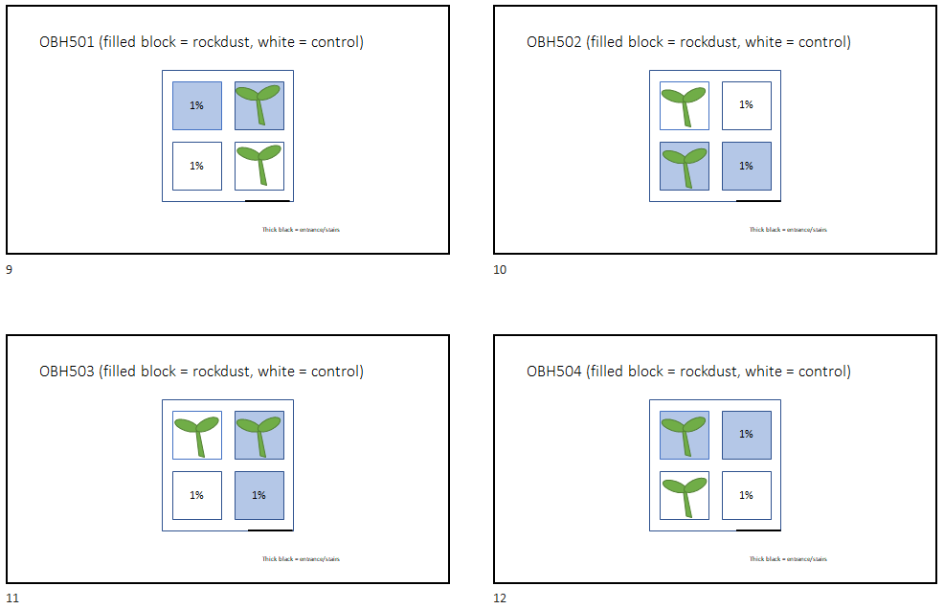

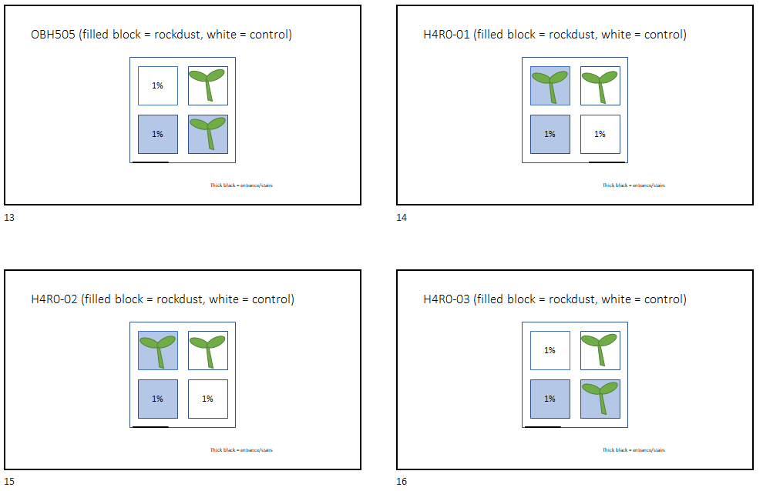

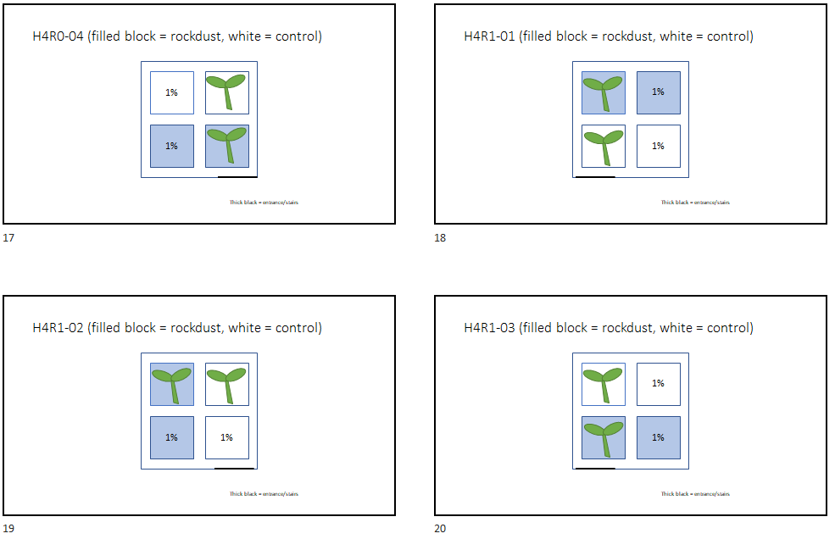

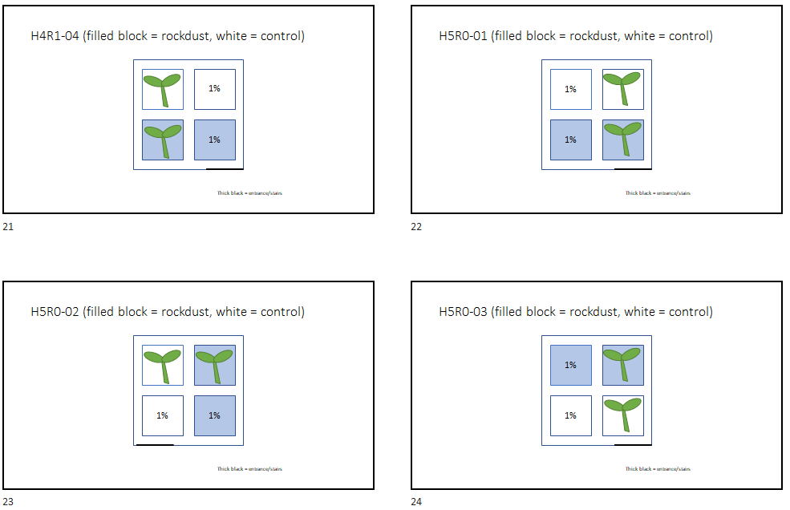

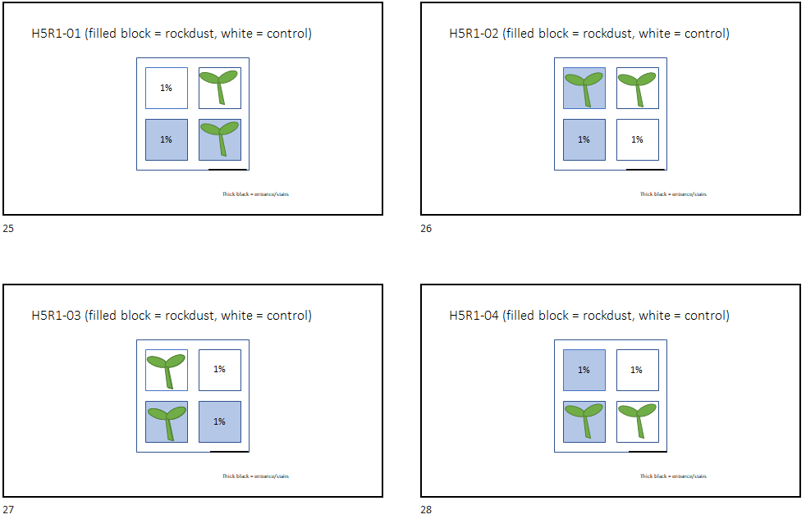

# Appendix D: Map of rock dust research sites

**Figure D1.** NP De Hoge Veluwe with the 24 rock dust experiment locations (locations with a red cross are camera traps excluded from this experiment). Sites with a red diamond shape have a camera trap control plot (CAM) that received 10t/ha Soilfeed early 2020 and as such an additional separate 5x5m control plot (C) in its vicinity. Sites with a red “circle” have been double sampled for soil microarthropods in the exclosures (all subplots instead of half) in 2020. Otterlose Bos site IDs are given as a number only, e.g. 5-04 is OBH5-04. All Otterlose Bos sites contain the Biowild Exclosure (EXB) and the rock dust exclosure (EXRD).

# Appendix E: Overview of all research sites belonging to this protocol

This appendix contains an overview of all the site of the Rock dust experiment, and the sites of the Biowild exclosures located in forest habitat.

Note that the camera plots outside the forest (in heath and drift sand habitats) are not yet included in this list.

The meaning of the variables is described below:

|  |  |
| --- | --- |
| **Variable** | **Meaning** |
| SiteID | Identification code of the site |
| Plot Types | Refers to the plot being located in an exclosure or its unfenced control. We use the following codes for plot type: EXB, CB, EXRD, CRD, and CAM.  Biowild plots are EXB and CB.  EXB = Biowild exclosure (size about 12x12m, lower stakes, includes a 10x10m plot with four 3x3m subplots)  CB = Biowild control plot (10x10m plot with 3x3m subplots) Rock dust plots are EXRD, CRD, and CAM. EXRD = rock dust exclosure (size about 13x13m, higher and slimmer stakes of which 2 subplots have white stakes and 2 subplots have blank stakes. four 5x5m subplots, no 10x10m plot).  CRD = Control plot rock dust (5x5m plot). Present on 12 out of 24 locations CAM = camera plot. In front of the camera trap there is a 10x10m plot with four 3x3m subplots *NOTE: CAM/CB = CAM plot is the same as CB plot. This is the case in 9 Otterlose Bos locations, as they have both EXB and EXRD.  Thus follow the Biowild protocol and take additional measurements for the rock dust experiment.* *NOTE2: In the dataset 2021 the distinction EXB and EXRD was made, but not the distinction CB and CRD (there mentioned as Controle and C). In 2020 the distinction was not made at all, but this can easily be traced back and standardised.* |
| Protocol Types | Whether to follow the Biowild protocol (Biowild), rock dust protocol (RockDust) or both (Both). |
| CAM Corner Dist | Empty if there is no CAM-plot. When there is a CAM-plot belonging to the rock dust experiment, the distance from the camera trap to the corner stake behind the camera trap is given in meters.  Officially this stake should have been placed 10m from the camera trap, but obstacles (e.g. old exclosures) prevented this in some cases.  If distance is zero, the camera trap IS the corner stake! |
| EXRD place | Whether the rock dust exclosure (constructed in 2020) is placed in front or back of the camera view, will be left empty if there is no EXRD |
| LAT/LON | GPS coordinates of the Site (but not the plots). |

|  |  |  |  |  |  |  |  |
| --- | --- | --- | --- | --- | --- | --- | --- |
| **SiteID** | **Plot Types** | **Protocol Types** | **CAM Corner Dist** | **EXRD place** | **LAT** | **LON** | **Remarks** |
| OBH102 | EXB, CAM | Biowild |  |  | 52.0805 | 5.7869 |  |
| OBH103 | EXB, CAM | Biowild |  |  | 52.0806 | 5.7833 |  |
| OBH104 | EXB, CAM | Biowild |  |  | 52.0863 | 5.7842 |  |
| OBH105 | EXB, CAM | Biowild |  |  | 52.0771 | 5.7881 |  |
| OBH401 | EXB, EXRD, CAM/CB | Both | 0 | Back | 52.0760 | 5.7889 |  |
| OBH402 | EXB, EXRD, CAM/CB, CRD | Both | 0 | Back | 52.0793 | 5.7964 |  |
| *OBH403* | EXB, CB | Biowild |  |  | 52.0795 | 5.7891 |  |
| OBH404 | EXB, EXRD, CAM/CB | Both | 3 | Front | 52.0867 | 5.7826 |  |
| OBH405 | EXB, EXRD, CAM/CB, CRD | Both | 1 | Back | 52.0825 | 5.7947 |  |
| OBH501 | EXB, EXRD, CAM/CB | Both | 0 | Back | 52.0824 | 5.7884 |  |
| OBH502 | EXB, EXRD, CAM/CB, CRD | Both | 5 | Front | 52.0857 | 5.7957 |  |
| OBH503 | EXB, EXRD, CAM/CB | Both | 0 | NA | 52.0827 | 5.7928 | Should note in 2022 where EXRDplace is! |
| OBH504 | EXB, EXRD, CAM/CB, CRD | Both | 0 | Front | 52.0868 | 5.7861 |  |
| OBH505 | EXB, EXRD, CAM/CB | Both | 10 | Back | 52.0828 | 5.7980 |  |
| H4R0_01 | EXRD, CAM | RockDust | 10 | Back | 52.0899 | 5.8088 |  |
| H4R0_02 | EXRD, CAM, CRD | RockDust | 10 | Front | 52.1089 | 5.7954 | vegetation plots are situated to the right  of the camera (when looking in the camera’s viewing direction) instead of in front of the camera. |
| H4R0_03 | EXRD, CAM | RockDust | 10 | Back | 52.1240 | 5.8471 |  |
| H4R0_04 | EXRD, CAM, CRD | RockDust | 10 | Back | 52.0729 | 5.8477 |  |

|  |  |  |  |  |  |  |  |
| --- | --- | --- | --- | --- | --- | --- | --- |
| **SiteID** | **Plot Types** | **Protocol Types** | **CAM Corner Dist** | **EXRD place** | **LAT** | **LON** | **Remarks** |
| H4R1_01 | EXRD, CAM, CRD | RockDust | 10 | Back | 52.0986 | 5.8443 |  |
| H4R1_02 | EXRD, CAM | RockDust | 3 | Back | 52.1037 | 5.8142 |  |
| H4R1_03 | EXRD, CAM | RockDust | 6 | Back | 52.0851 | 5.8121 |  |
| H4R1_04 | EXRD, CAM, CRD | RockDust | 0 | Front | 52.0886 | 5.8398 |  |
| H5R0_01 | EXRD, CAM | RockDust | 10 | Front | 52.0383 | 5.8451 |  |
| H5R0_02 | EXRD, CAM, CRD | RockDust | 10 | Front | 52.1053 | 5.8661 |  |
| H5R0_03 | EXRD, CAM, CRD | RockDust | 8.5 | Back | 52.0604 | 5.8368 |  |
| *H5R0_04* | *CB* | *Biowild* |  |  | *52.0573* | *5.8585* | Monitoring cancelled since 2020 due to  wood harvest (for heathland development?) |
| H5R1_01 | EXRD, CAM | RockDust | 10 | Back | 52.0514 | 5.8444 |  |
| H5R1_02 | EXRD, CAM, CRD | RockDust | 10 | Front | 52.1081 | 5.8592 |  |
| H5R1_03 | EXRD, CAM | RockDust | 10 | Back | 52.0578 | 5.8221 |  |
| H5R1_04 | EXRD, CAM, CRD | RockDust | 10 | Front | 52.0390 | 5.8631 |  |

|  |  |  |  |  |  |  |  |
| --- | --- | --- | --- | --- | --- | --- | --- |
| **SiteID** | **Plot Types** | **Protocol Types** | **CAM Corner Dist** | **EXRD place** | **LAT** | **LON** | **Remarks** |
| NPHV-1 | EXB, CB | Biowild |  |  | 52.1165 | 5.8578 |  |
| NPHV-2 | EXB, CB | Biowild |  |  | 52.1170 | 5.8353 |  |
| NPHV-3 | EXB, CB | Biowild |  |  | 52.0908 | 5.8082 |  |
| NPHV-4 | EXB, CB | Biowild |  |  | 52.0900 | 5.8076 |  |
| NPHV-5 | EXB, CB | Biowild |  |  | 52.0930 | 5.7950 |  |
| NPHV-6 | EXB, CB | Biowild |  |  | 52.1155 | 5.8160 |  |
| NPHV-7 | EXB, CB | Biowild |  |  | 52.1154 | 5.8154 |  |
| NPHV-11 | EXB, CB | Biowild |  |  | 52.0543 | 5.8464 |  |
| NPHV-12 | EXB, CB | Biowild |  |  | 52.0657 | 5.8346 |  |
| NPHV-13 | EXB, CB | Biowild |  |  | 52.0682 | 5.8314 |  |
| NPHV-14 | EXB, CB | Biowild |  |  | 52.0843 | 5.8298 |  |
| NPHV-15 | EXB, CB | Biowild |  |  | 52.0873 | 5.8196 |  |
| NPHV-21 | EXB, CB | Biowild |  |  | 52.0368 | 5.8489 |  |
| NPHV-22 | EXB, CB | Biowild |  |  | 52.0385 | 5.8478 |  |
| NPHV-23 | EXB, CB | Biowild |  |  | 52.0372 | 5.8376 |  |
| NPHV-24 | EXB, CB | Biowild |  |  | 52.0385 | 5.8411 |  |
| NPHV-25 | EXB, CB | Biowild |  |  | 52.0394 | 5.8386 |  |
| NPHV-31 | EXB, CB | Biowild |  |  | 52.1079 | 5.8511 |  |
| NPHV-32 | EXB, CB | Biowild |  |  | 52.1073 | 5.8575 |  |
| NPHV-33 | EXB, CB | Biowild |  |  | 52.1014 | 5.8462 |  |
| NPHV-34 | EXB, CB | Biowild |  |  | 52.1030 | 5.8377 |  |
| NPHV-35 | EXB, CB | Biowild |  |  | 52.0935 | 5.8412 |  |

# Appendix F: Determinatie conifeer zaailingen

Determinatiesleutel zaailingen naaldbomen

Leo Goudzwaard, 2020

Op verzoek heb ik jonge zaailingen van een paar soorten naaldbomen bekeken en verschillen gezocht. Omdat zaailingen van coniferen zoveel op elkaar lijken.

Zaailingen van de Buunderkamp.

Abies zaailingen van internet-fotos bekeken.

Voor onderstaande naaldkenmerken is wel een loep nodig.

Er moeten wel naalden aanzitten, de kiemlobben alleen is niet genoeg.

Stuur maar door aan studenten die er nog mee bezig zijn.

Grove den: gezaagde bladrand; is een prima onderscheidend kenmerk.

Picea (ik heb alleen nog sitchensis bekeken; en geldt ws ook voor fijnspar): naald niet afgeplat, duidelijk gekield aan de onderzijde.

Picea sitchensis: scherpe doorzichtige naaldpunt; knop niet gepunt.

Douglas: naald afgeplat, iets gekield; gegroefde naaldbovenzijde; naaldvoet niet aflopend op de twijg, scherpe punt, iets doorzichtig; knop puntig

Japanse lariks: naald afgeplat, iets gekield; naaldbovenzijde niet of nauwelijks gegroefd; naaldvoet aflopend op de twijg; scherpe punt iets doorzichtig; knop niet gepunt, vrijwel rond.

Abies (alba en grandis) naald afgeplat; bovenzijde gegroefd; naaldtop niet scherp.

Dan zou ik het volgende sleuteltje voor bovenstaande soorten kunnen maken:

1a naaldrand gezaagd: *Pinus* (*sylvestris* of *nigra*)

1b naaldrand niet gezaagd: 2

2a naalden afgeplat, onderzijde licht gekield: 3

2b naalden niet afgeplat, onderzijde duidelijk gekield: *Picea*

3a naaldvoet aflopend op de twijg; naaldbovenzijde niet of nauwelijks gegroefd; knop niet puntig, vrijwel rond: *Larix*

3b naaldvoet niet aflopend: 4

4a naaldtop scherp gepunt; knop puntig: *Pseudotsuga*

4b naaldtop afgerond tot stomp puntig (of uitgerand); knop niet puntig: *Abies*

# Appendix G: **Determinatie loof- en naaldbomen** (betere kwaliteit PDF beschikbaar)

